First Calvary Baptist Church
Scholarship Ministry

Elnora Shields
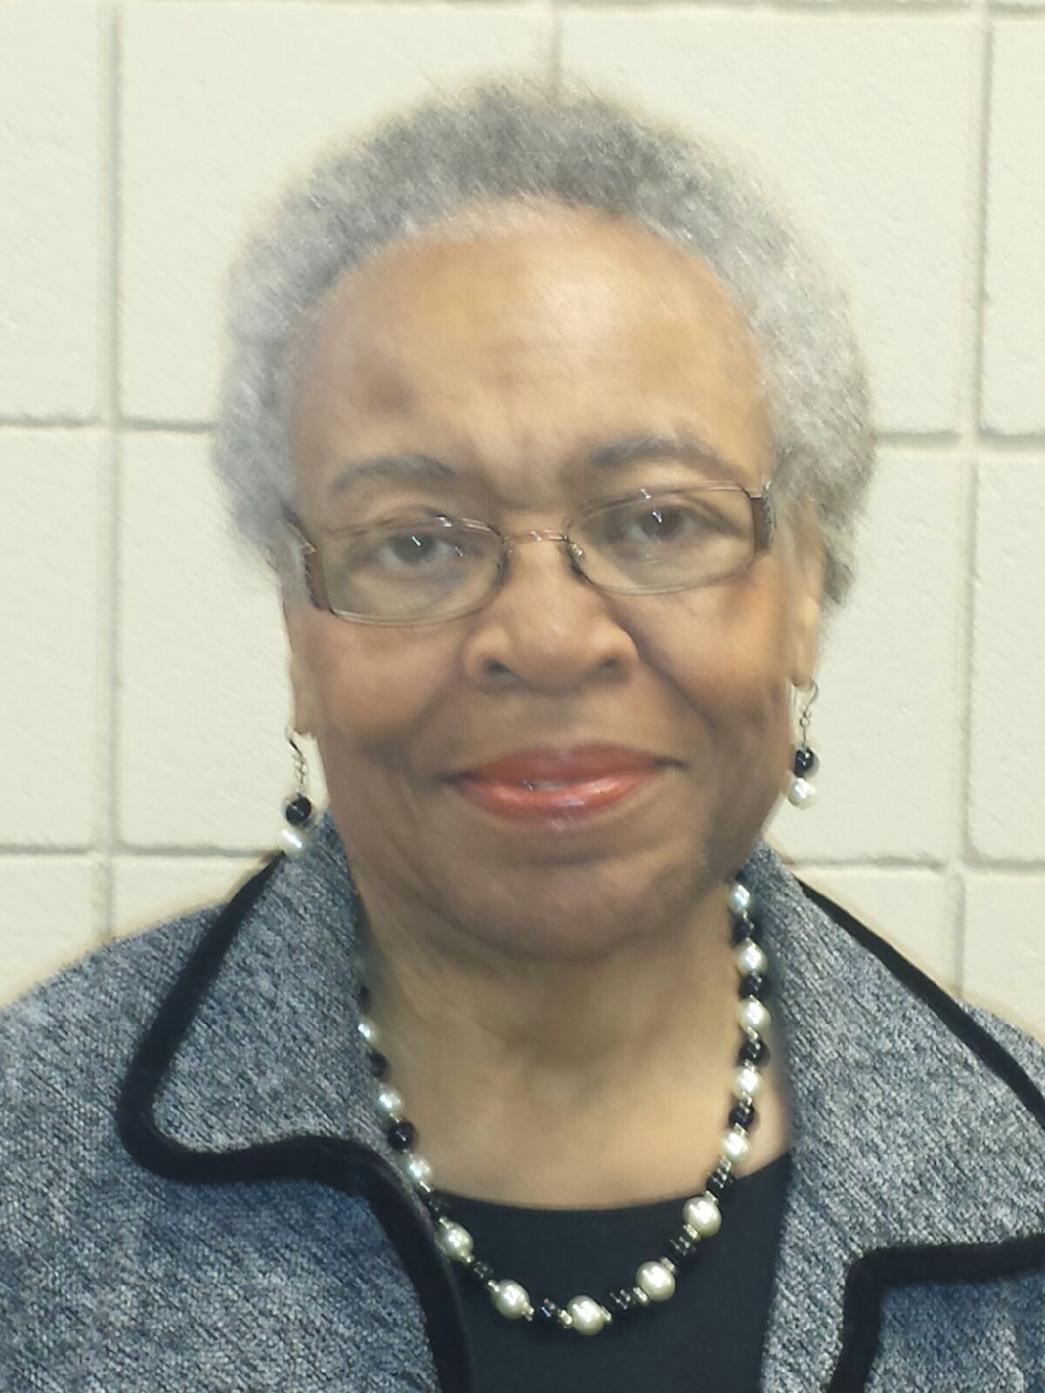

Academic Scholarship Application

CRITERIA
The recipient of the First Calvary Baptist Church $1500 Academic Scholarship will be selected on the basis of academic achievement (GPA) and church membership. Each applicant should also include a written essay and two recommendation letters to complete the packet. The recipient(s) will be REQUIRED to attend the reception on Graduation Sunday.

ACADEMICS
Students must currently have a “3.5” or greater unweighted grade point average. Only unweighted GPAs will be considered because some private schools do not use weighted grade point averages.

ESSAY
The applicant will complete a 250-word typed, double-spaced essay in which you describe your goals, how you plan to achieve them, and how an education will help you make a contribution to your community.

CHURCH MEMBERSHIP
Student should be a member or affiliate of the body of First Calvary Baptist Church.
Membership (for the purposes of the FCBC Scholarship) is defined as a student who is a member through 1) baptism, Christian experience, Associate membership; 2) has a parent/legal guardian who is a member of First Calvary and actively participating in the life of the church; and 3) active participant in church ministries and consistent attendance in worship.
Affiliate is defined as a student who participates in FCBC outreach ministries such as, Scouts or Recreation Ministry.

Involvement is defined as an active/consistent participation in a church ministry (i.e., worship, fellowship, evangelism, discipleship, Sunday school, and Bible study ministries). Involvement is considered as participation from April 2023- April 2024.

The Chairperson of the ministry must provide written confirmation of student’s active participation in the ministry for the current school year.

The following is a list of typed documents that each student must provide/fill out completely for the Elnora Shields Academic Scholarship.

- Application for the “FCBC Scholarship”
- Copy of high school (official) transcript (issued by the Guidance Counselor)
- Church /Ministry Statement – Must be signed by Ministry Chairperson
- 250 word typed essay (completed and signed by student) Separate from Katara Harris Merit essay
- *Two (2) personal recommendation letters (see below). These letters must be completed and signed by persons recommending the student for the scholarship
- PROOF of ADMISSION TO AN INSTITUTION OF HIGHER LEARNING

All items must be submitted to First Calvary Baptist Church Scholarship Ministry email at scholarship@firstcalvary.org, (NO LATER THAN WEDNESDAY, April 24, 2024 at 5pm.) (All Scholarship application packets WILL ONLY be received via Email to the Scholarship Ministry email address.

*Written recommendations must be from the following: one (1) church member (excluding the Pastor and parents), and one (1) from the following: guidance counselor, teacher, coach, etc. Recommendations should be no more than 100 words typed clearly describing the applicant’s personal drive. Two (2) letters of recommendation are required and must be typed and signed.

***IMPORTANT!!! Please make sure that ALL 6 items above are completed and submitted together via email. Incomplete packets WILL NOT be accepted for consideration. To prevent late arrival, plan early to have your transcript and recommendation letters available to you so they can be added to your application packet materials to be included with your total packet, when submitting to the Scholarship Ministry email address at scholarship@firstcalvary.org.

DEADLINE
The Scholarship Ministry must receive all Application Packet Materials at the Scholarship Ministry email address at scholarship@firstcalvary.org (NO LATER THAN Wednesday, April 24, 2024 at 5pm). LATE APPLICATIONS WILL NOT BE ACCEPTED! If there are questions concerning the contents of the Scholarship Application Packet, please send an email to the Scholarship Ministry email address at scholarship@firstcalvary.org.

If there are questions concerning the contents of the Scholarship Application Packet, please send an email to the Scholarship Ministry email address at scholarship@firstcalvary.org.

First Calvary Baptist Church
Elnora Shields Academic Scholarship Application

NAME____________________________________________________________

ADDRESS_________________________________________________________

BIRTHDATE______________________ SEX: Male_______ Female______

PARENTS/GUARDIANS ____________________________________________

HOME TELEPHONE_______________________________________________

CELL PHONE_____________________________________________________

EMAIL ADDRESS ___________________________________________________

HIGH SCHOOL____________________________________________________

DATES ATTENDED________________________________________________

HONORS__________________________________________________________

___________________________________________________________________

___________________________________________________________________

ARE YOU OR YOUR PARENTS OR GUARDIAN A MEMBER OF FIRST CALVARY? Yes_____ No_____

CHURCH ACTIVITIES/MINISTRIES___________________________________

____________________________________________________________________

____________________________________________________________________

____________________________________________________________________

NAME AND LOCATION OF COLLEGE/UNIVERSITY YOU WILL ATTEND:

First Calvary Baptist Church
Scholarship Packet FINAL CHECKLIST
For Elnora Shields Academic Scholarship

- Scholarship Application:
Students may apply for both but may only receive one scholarship.

  - Elnora Shields Academic Scholarship _____Yes or No______
  - Katara Harris Merit Award _____Yes or No______

- Official Copy of high school transcript (issued by the Guidance Counselor)
- Community Service Form(s)-Must be signed by the Community Service Rep.
**Only Required for Katara Harris Merit Award**
- Church/Ministry Statement – Must be signed by Ministry Chairperson
- 250 word typed essay (completed and signed by student)
- *Two personal recommendation letters. These must be completed and signed by persons recommending the student for the scholarship.
- Proof of acceptance to an institution of higher learning

I have used the above checklist to validate that my application packet is complete and includes all of the items listed above for the appropriate scholarship.

I understand that I may apply for either scholarship or both. I also understand that only completed application packets will be considered and I must submit the above items to the Scholarship Ministry email address at scholarship@firstcalvary.org, NO LATER THAN Wednesday, April 24, 2024 at 5pm. Please note that scholarship application packets WILL ONLY be received/accepted via the scholarship ministry email address.

Student Signature _____________________________________________________

_______________________________________________________________________

